# SOCIAL

## TECHWOLVES

***Team Details***

|  |  |  |  |  |  |
| --- | --- | --- | --- | --- | --- |
| **Participant Name** | **CT /DT**  **Number** | **Role (Team Leader**  **/ Member)** | **Bachelors Discipline** | **Expected Year of Passing** | **Gender** |
| NAVEEN ANTONY | CT20192659599 | **TEAM LEADER** | ELECTRICAL AND ELECTRONICS ENGINEERING | 2020 | M |
| SHYAM MITTAL | CT20192657885 | **TEAM MEMBER** | ELECTRICAL AND COMMUNICATION | 2021 | M |
| ANSH MEHTA | CT20182591537 | **TEAM MEMBER** | ELECTRICAL AND COMMUNICATION | 2021 | M |
| ARYAN MEHTA | CT20192661914 | **TEAM MEMBER** | COMPUTER SCIENCE ENGINEERING | 2021 | M |

# SOCIAL

1. **Use Case Overview**

The proposal is titled “**SMART PRODUCTS” under** the theme “**LIFE SCIENCES**”. Our goal of the project is to create a Smart Health Monitoring System with the implementation of Brain Computer Interface, Chinese Pulse Detection and Biosensors. Classification Algorithms and Decisions Making Algorithms are made in Machine learning, Neural Based Algorithms and IoT for Communication and Decision making. Communication to the end user and the person who supports in emergency is done through IoT.

Apart from this monitoring the health, Our goal is to provide instant medical advices and support system. Apart from the transmission and communication protocol, we also provide a safety system for the person like emergency contact alerting, Give Alerts to the nearby hospitals and bring care for patient.

## Use Case Description

The Design and Development of Health Monitoring has garnered lot of attention in the scientific community and the industry during the last years. Health Monitoring Devices are becoming a vital requirement in everyone’s life. 151,600 people die each day, 6,316 people die each hour because of accidents, improper healthcare, some die without knowing the reason at all which may be due to heart attack, brain Death, Cancer. Children, adults, Teens everyone is affected someday by some infection or disease due to irregular care taken themselves.

Nowadays, there are smart watches which monitor one or two vitals like rate and blood pressure. Some of watches even have the provision of fall detection. But only there are only few devices which concentrate on full scale health monitoring.

Biosensors are capable of measuring significant physiological parameters like heart rate, blood pressure, body and skin temperature, oxygen saturation, respiration rate, electrocardiogram, electromyogram, electroencephalogram etc. These all together form a health monitoring system and with help of Iot, Machine learning/AI it becomes smarter.

One of the major problems that every user is the false detection in case of alert based system where there are unwanted alarms buzzed. Another issue is the accuracy of the results which are detected which can be increased by better decision making structure and classification algorithms

Not only have the people who are affected by diseases or who are conscious about the health used these device. Every person can use these devices which is really essential for his/her wellness.

Key Customers of Smart Health Care devices are,

* Patients who are advised to be under critical monitoring
* Diabetes Patients
* Heart Patients
* Paralyzed patients

## Current system

Current systems which are present separately. Those systems can detect provide alerts which can give the valuable information but cant provide the required mesure to be taken to solve that issue. MI watch, apple watch , Glucometer kardiograph are devices are present in these monitoring.

## Proposed solution

Our solution is that we are going to make device which consists of three advanced monitoring systems,

* Brain Computer Interface.
* Chinese Pulse Detection.
* Vitals monitoring like heart rate, blood pressure, body and skin temperature, oxygen saturation, respiration rate.

When it comes to brain computer interface, we are looking into EEG – Electroencephalogram which can be used to detect Head injuries, head ach, Brain death confirmation, Sleep disorders, and psychiatric disorders. This all can be detected through the EEG waveform but we are proposing Brain computer interface mainly for the paralyzed, neuromuscular patients. Our proposed idea can be used by all kind of people. Brain Computer Interface is a non-invasive which can be either motor imagery or visual stimuli. Motor Imagery is by thought process where all those actions are detected to make decisions. Motor Imagery frequency ranges above 13Hz. We can use frequency classification to detect all those.

Second is the Chinese pulse detection where we work on we detect the pulses from the hands and we use ML algorithm for decision making. We will be sitting with doctors who are in fields of Ayurveda where they will be working on these in person. We collect a data base and we match that database to the pulse data received.

Third is the vitals monitoring like respiratory rate from piezoelectric/piezoresistive sensor , oxygen saturation from pulse oximeter, skin conductivity from galvanic skin response, like these we will getting data from different sensors which will depict different illness.

The vitals which can be detected through sensors,

1. Blood Pressure – Arm cuff based Monitor - Refers to the force exerted by circulating blood on the wall of blood vessels
2. Skin Temperature – Temperature Probe – A measure of the body’s ability to generate and get rid of heat.
3. Respiration Rate - piezoelectric/piezoresistive sensor – Number of movements indicative of inspiration and expiration per unit time
4. Oxygen Saturation – Pulse Oximater – Indicates the oxygenation or the amount of oxygen that is being carried in patients blood
5. Heart Rate - Pulse Oximater – Frequency of the cardiac cycle
6. Perspiration - galvanic skin response- Electrical conductance of the skin
7. Heart sounds – Phonocardiograph – A record of heart sounds
8. EMG – Skin Electrodes – Muscle Activity
9. Body Movements – Accelerometer – Measurement of acceleration forces in the 3D Space

All these data from these methods are from processed through the decision making and classification algorithms which in turn will provide results. The results and data are stored in the Google cloud platform. WE are using IOT for notification and alert systems. We are implementing the sensors by powering up with help of body heat.

## Architecture

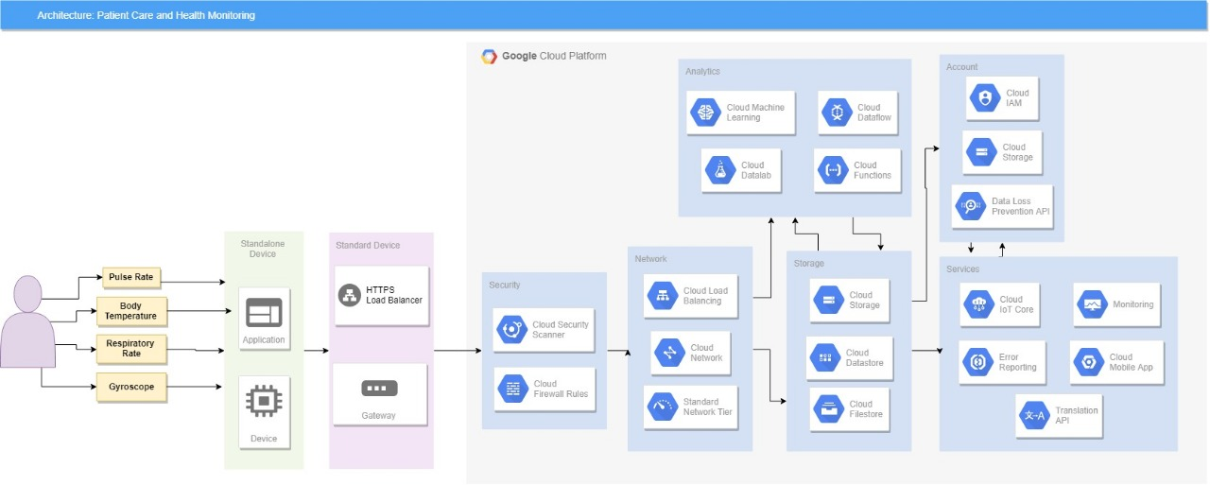

## 

## Productization

## We will be adding all these 3 technologies to a single device where we can measure everything and transport everything to the doctor or the care taker. We will scaling the product to simple wearable devices with sensors attached to body or we are planning to make it as smart tshirt. We have already tested the environment of brain computer interface and we have received output of 87.5% accuracy for 40 subjects. We will testing Chinese pulse detection and Vital monitor in real time environment by giving the prototype to subjects. We need atleast 18 subjects accurate results to determine the device usability.

1. **Tools and Environment**

When it comes to sensors we will using the following ones,

1. Blood Pressure – Arm cuff based Monitor - Refers to the force exerted by circulating blood on the wall of blood vessels

2. Skin Temperature – Temperature Probe – A measure of the body’s ability to generate and get rid of heat.

3. Respiration Rate - piezoelectric/piezoresistive sensor – Number of movements indicative of inspiration and expiration per unit time

4. Oxygen Saturation – Pulse Oximater – Indicates the oxygenation or the amount of oxygen that is being carried in patients blood

5. Heart Rate - Pulse Oximater – Frequency of the cardiac cycle

6. Perspiration - galvanic skin response- Electrical conductance of the skin

7. Heart sounds – Phonocardiograph – A record of heart sounds

8. EMG – Skin Electrodes – Muscle Activity

9. Body Movements – Accelerometer – Measurement of acceleration forces in the 3D Space

* Apart from these we will using BOLT IOT Transmission and communication.
* We will using Raspberry pie for the Data Acquisation through EEG Sensors, and we will making device 3d printed to add upp all these extensions.

## Simulation & Testing

Labview and python will be used for testing and simulating this device. As we know that Python open source and Labview is user friendly. They both provide a solid base for our device to work on. We are using Labview for Real time testing, where we can get know the real time plots and all the monitored vitals can plotted real time. We are making it through Labview to make it more user friendly and reducing complexity. ML Algorithms are coded in python and they will be invoked in labview which turn changes into block where inputs and outputs can be given. This brings us a device with less complexity

## Cloud Platform

## We will be using google cloud platform for the storage which we have clearly mentioned through the architecture.

## Physical

NODE MCU

RASPBERRY PIE

BOLT IOT

NI DAQ